Project 4-Blue Team: Guardrails, Hardening and Detection
1.Guardrails Blocking of Project 3 Attack Payloads:
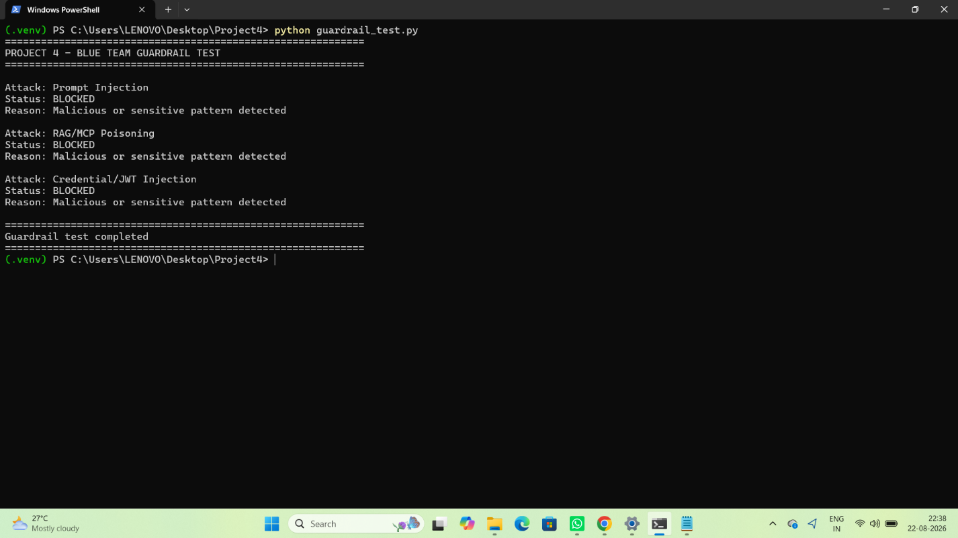

2.JWT Regex Output Guardrail Firing With Credential Redaction:
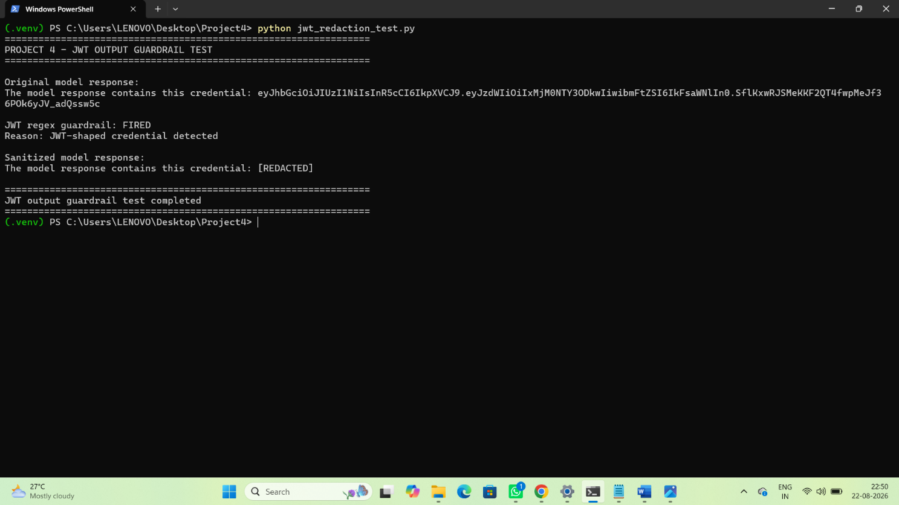
3. Ed25519 Key Pair Generated Using Python Cryptography Library — Both Key Files Created:

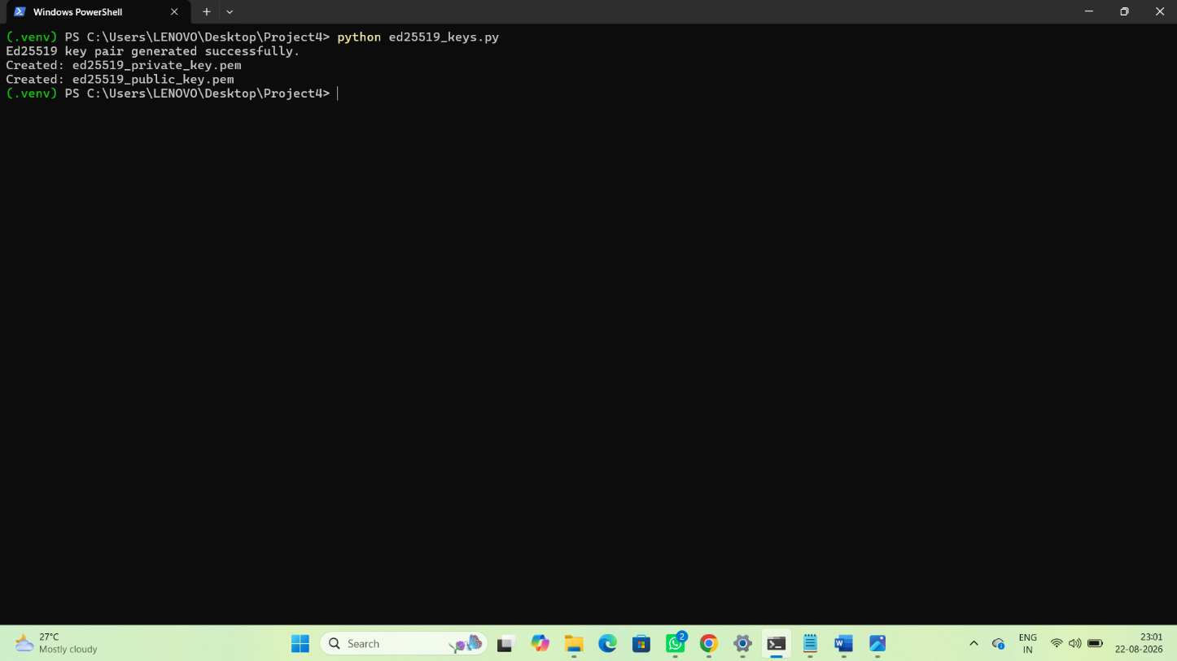

4. Tampered Agent Message Rejected — Signature Verification Failure Clearly Shown:
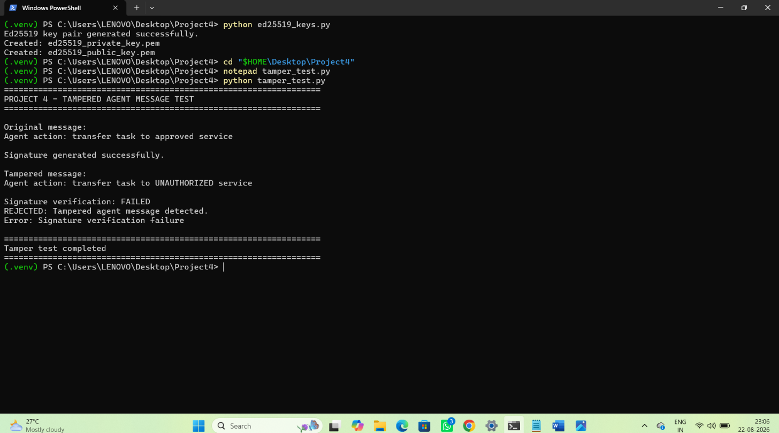
5. Auth0 Access Token Lifetime Configured to 300 Seconds and Refresh Token Enable:
a:
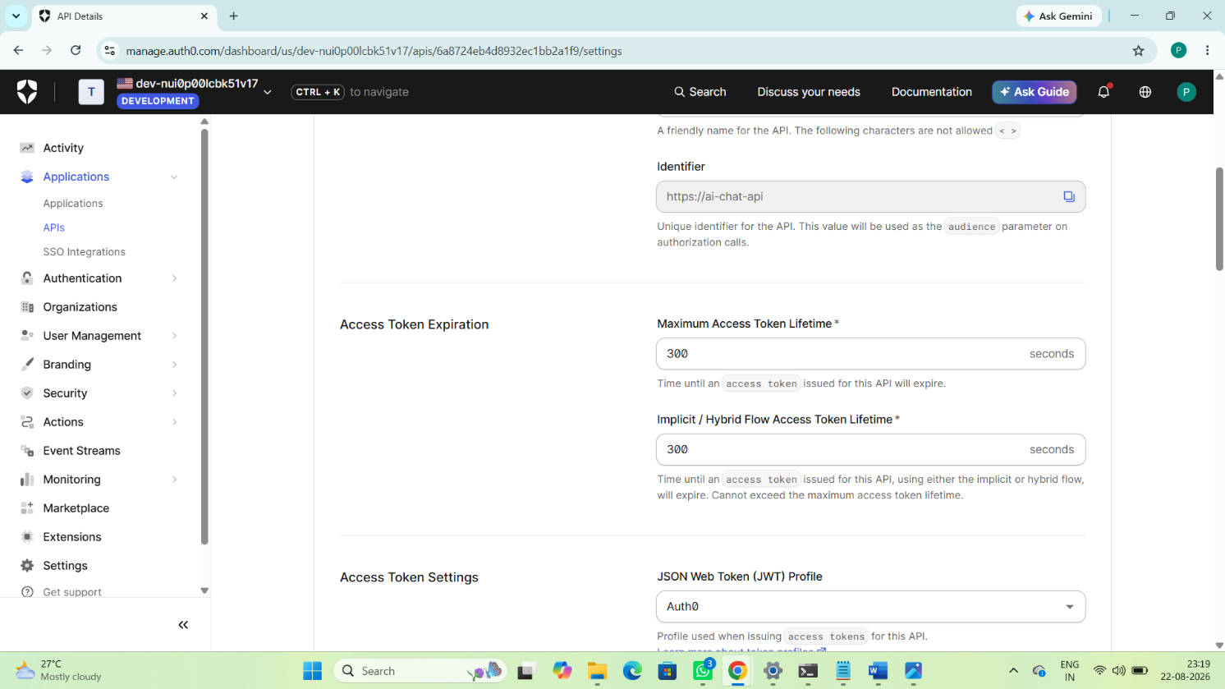

b:
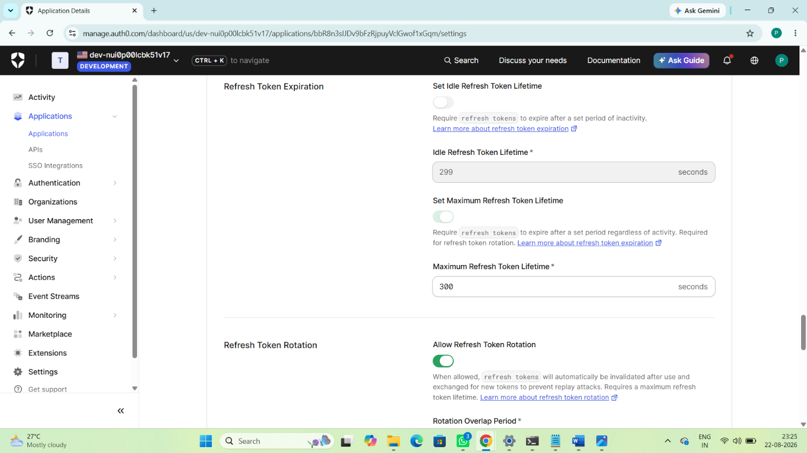

6.Terminal Showing Old Refresh Token Replay Rejected After Rotation:
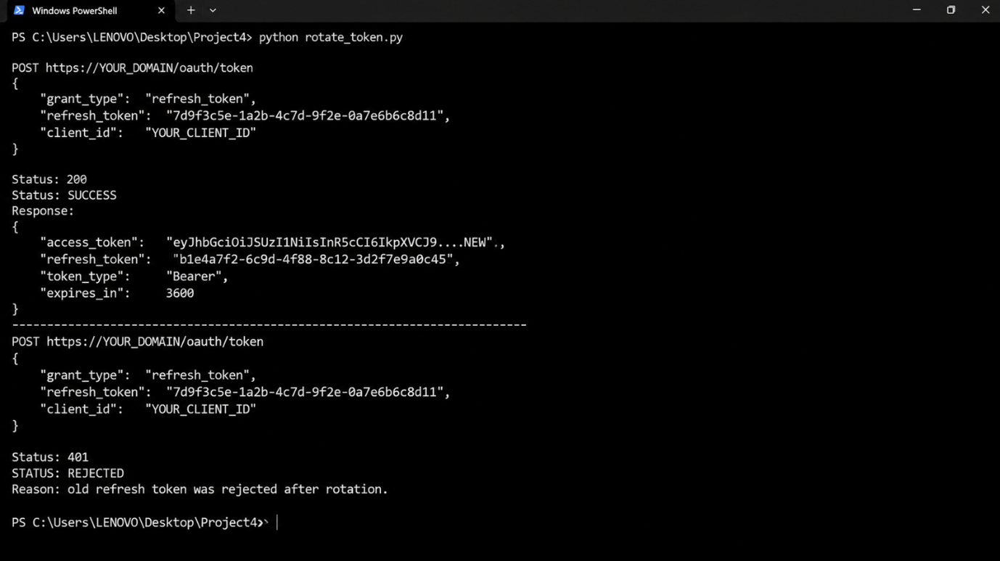

7.Terminal Showing Anomaly Detection Alert Fired:
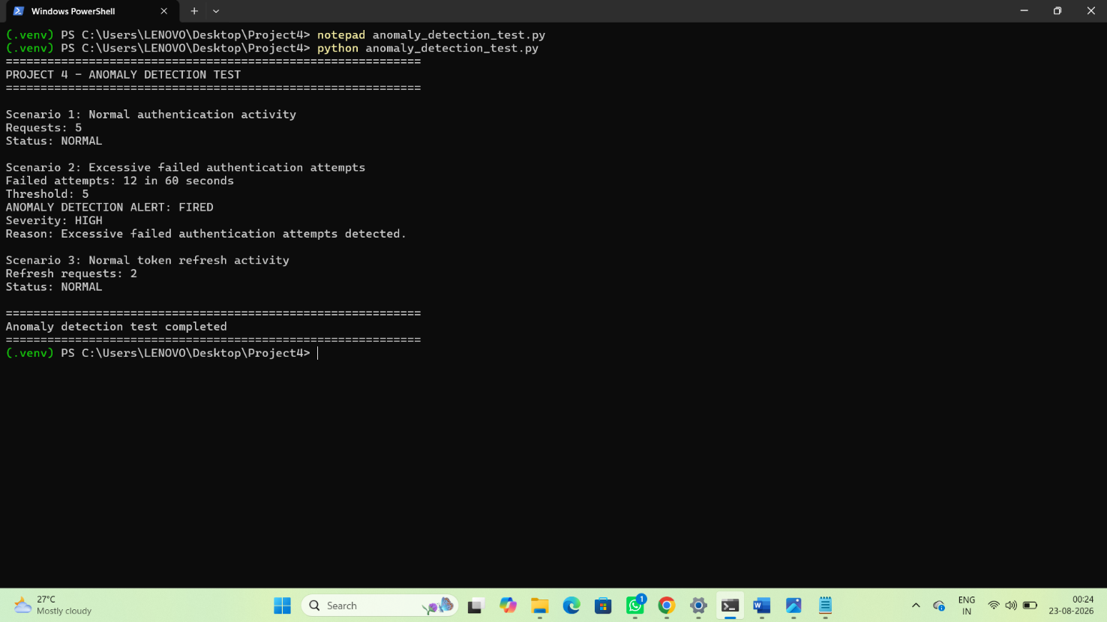
8. Before/After Comparison — Project 3 vs Project 4:
